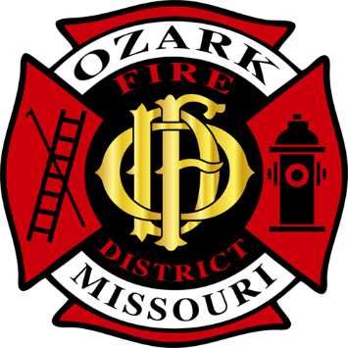 | Ozark Fire District
 | Jarett Metheny
 | Fire Chief
 | jmetheny@ozarkfire.org
 | 604 N. 3rd Street |  | PHONE: | (417) 581-4436
 | P.O. Box 917 |  | FAX: | (417) 581-4496
 | Ozark, MO 65721 |  | WEB: | www.ozarkfire.org

Ozark Fire Protection District – Board of Directors
October 15, 2024, Regular Meeting Minutes

Board President Will Reynolds called a meeting of the Ozark Fire Protection District's Board of Directors to order at 6:00 p.m. on October 15, 2024.

Pledge of Allegiance and Ceremonial Matters.

Roll Call. Directors Present: President Reynolds, Director Dobbs, Director Johns, and Director Price.
Staff Present: Secretary York, Chief Metheny, Chief Owens, Chief Heaton, and Chief Athens.

Approval of Agenda.
President Reynolds presented the agenda for revision and/or approval. Director Dobbs moved to accept the agenda. Director Johns provided a second, and all Directors voted in favor.

Acceptance of Previous Meeting Minutes.
The minutes for the regular meeting on Tuesday, September 17, 2024, were presented. Director Johns motioned to approve the minutes; Director Dobbs provided a second, and all Directors voted in favor.

The minutes for the special meeting on Tuesday, September 25, 2024, were presented. Director Dobbs motioned to approve the minutes; Director Johns provided a second, and all Directors voted in favor.

Public Comments. There were no previously registered guests.

Financial Report.
Chief Metheny presented an overview. Director Dobbs motioned to approve the financial report, and Director Price provided a second. All Directors voted in favor.

District Monthly Report.
Staff provided a monthly report of activities and events.

Old Business.
- Discussion and Consideration of Approving a Service Agreement with Cirrus Payroll.
  - Director Johns made a motion to approve the Service Agreement. Director Dobbs provided a second, and all Directors voted in favor.
New Business.
- Discussion and Presentation of the 2025 Draft Budget.
  - Director Johns moved to accept the draft budget. Director Dobbs seconded, and all Directors voted in favor.

Adjournment.
Director Johns motioned to adjourn the meeting at 6:45 pm and enter a closed session per RSMO 610.021(2), (3), and (9). Director Dobbs provided a second. All Directors present voted in favor.
Closed Session.
The Board President called the closed session to order at 6:50 pm. A roll call was taken, and the following Directors were present:
Directors Present: President Reynolds, Director Dobbs, Director Johns, and Director Price.
Staff Present: Chief Metheny.

During the closed session, the following discussions were made with no action taken.
  - RSMo 610.021(2) – Leasing, Purchase, or Sale of Real Estate.
  - RSMo 610.021(3) – Hiring, Firing, Disciplining or Promoting of Particular Employees.
  - RSMo 610.021(9) – Preparation for Negotiations with Public Employees.

Adjournment.
Director Johns motioned to adjourn the closed session meeting at 7:25 p.m. and enter an open session. Director Dobbs provided a second. All Directors present voted in favor.
Open Session.
The Board President called the open session to order at 7:30 pm. A roll call was taken, and the following Directors were present:
Directors Present: President Reynolds, Director Dobbs, Director Johns, and Director Price.
Staff Present: Chief Metheny

The Board reported that discussions were held, but no action was taken regarding RSMo 610.021(2), (3), and (9).

Adjournment.
Director Johns motioned to adjourn at 7:35 p.m. Director Dobbs provided a second. All Directors voted in favor.

Approved By: ______________________________ Date: ______________________________
Jarett Metheny, Fire Chief

The news media may obtain copies of this notice by contacting:
Ozark Fire Protection District Office
604 N. 3rd Street, Ozark, MO 65721

