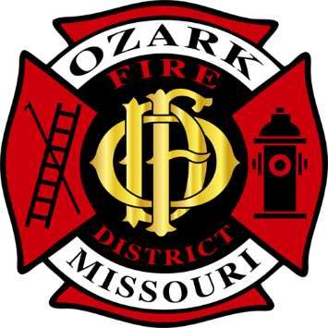 | Ozark Fire District
 | Jarett Metheny
 | Fire Chief
 | jmetheny@ozarkfire.org
 | 604 N. 3rd Street |  | PHONE: | (417) 581-4436
 | P.O. Box 917 |  | FAX: | (417) 581-4496
 | Ozark, MO 65721 |  | WEB: | www.ozarkfire.org

Ozark Fire Protection District – Board of Directors
December 17, 2024, Regular Meeting Minutes

Board President Will Reynolds called a meeting of the Ozark Fire Protection District's Board of Directors to order at 6:00 p.m. on December 17, 2024.

Pledge of Allegiance and Ceremonial Matters.

Roll Call. Directors Present: President Reynolds, Director Dobbs, Director Johns, Director Growcock, and Director Price.
Staff Present: Secretary York, Chief Metheny, Chief Owens, and Chief Crawford.

Approval of Agenda.
President Reynolds presented the agenda and requested an amendment to include a closed session per RSMo 610.021(3). Director Johns moved to accept the amended agenda. Director Price provided a second, and all Directors voted in favor.

Acceptance of Previous Meeting Minutes.
The minutes for the regular meeting on Tuesday, November 19, 2024, were presented. Director Growcock motioned to approve the minutes; Director Dobbs provided a second. All other Directors voted in favor.

Public Comments. There were no previously registered guests.

Financial Report.
Director Dobbs presented an overview. Director Johns motioned to approve the financial report, and Director Price provided a second. All Directors voted in favor.

District Monthly Report.
Staff provided a monthly report of activities and events.

Old Business.
- A revised budget was submitted for discussion and consideration. Since the budget was approved last month, staff have received detailed information regarding insurance and Lagers. Chief Metheny presented an overview of the changes. The Board took no action since then, and there were no substantial changes.
New Business.
- Discussion and Consideration of Approving the Purchase of Auto-Extrication Equipment.
  - Director Growcock moved to approve the purchase of auto-extrication equipment from Jon’s Mid-America for $32,966 as a sole source provider (see Board Packet) to be paid from bond funds. Director Price provided a second and all Directors voted in favor.

Adjournment.
      - Director Dobbs motioned to adjourn the meeting at 6:16 p.m. and enter a closed session per RSMO 610.021(3) to discuss an anonymous letter from a concerned citizen sent to the Board Members. A roll call vote was taken, and all Directors voted in favor.
Closed Session.
            - President Reynolds called the closed session to order at 6:18 p.m. with a roll call. All Directors, including Chief Metheny, were present.
            - The Board discussed and reviewed the letter with Chief Metheny. They concluded with the following statement:
The Board has received an anonymous letter that purports to set forth many operational claims and allegations. As a general rule, anonymous letters are not given much weight. Judgment on the matter is refrained until the Board has given it to the District Relations Committee (DRC) and done due diligence on these internal operational matters.
            - Director Dobbs motioned to adjourn the closed session at 6:40 p.m. and enter an open session. Director Johns provided a second. A roll-call vote was taken to adjourn and enter an open session, and all Directors voted in favor.
Open Session.
- The Board President called the open session to order at 6:41 pm. A roll call was taken, and all Directors were present, including Chief Metheny
- The Board reported on the action taken in closed session.
Adjournment.
Director Price motioned to adjourn at 6:45 p.m. Director Dobbs provided a second. All Directors voted in favor.

Approved By: ______________________________ Date: ______________________________
Jarett Metheny, Fire Chief

The news media may obtain copies of this notice by contacting:
Ozark Fire Protection District Office
604 N. 3rd Street, Ozark, MO 65721

