|  |  |  |  |  |
| --- | --- | --- | --- | --- |
| Ozark Maltese Cross Flat | **Ozark Fire Protection District** | | | |
| Jarett Metheny | | | |
| *Fire Chief* | | | |
|  | | | |
| 604 N. 3rd Street |  | PHONE: | (417) 581-4436 |
| P.O. Box 917 |  | FAX: | (417) 581-4496 |
| Ozark, MO 65721 |  | WEB: | www.ozarkfire.org |
|  | | | | |

Posted: Wednesday, March 12, 2025, at 5:00 p.m.

Notice is hereby given that the Ozark Fire Protection District will conduct a meeting on

**Tuesday, March 18, 2025, at 6:00 pm at**

**Ozark Fire Protection District, 604 N. 3rd Street, Ozark, MO**

**The tentative agenda of this meeting includes:**

1. Pledge of Allegiance and Ceremonial Matters.
2. Call to Order.
   1. Roll Call.
   2. Approval of Agenda.
   3. Acceptance of the February 18, 2025, Regular Board Meeting Minutes.
   4. Previously Registered Guest.
3. Financial Report.
4. Staff Report
   1. Ozarkfire.org Email for Board Members
   2. Bond Informational Material
5. Old Business.
   1. Discussion and Consideration of Updated PowerDMS Service Agreement.
6. New Business.
   1. None
7. Adjournment.

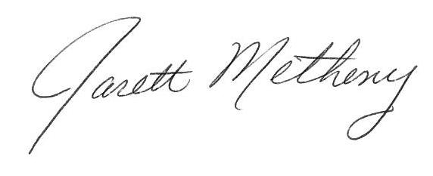

Submitted By: ______________________________ Date: March 12, 2025

Jarett Metheny, Fire Chief

The news media may obtain copies of this notice by contacting:

Ozark Fire Protection District Office

604 N. 3rd Street, Ozark, MO 65721